# RMIT University

# —

# COSC2196

# Introduction to Information Technology

# Assessment 2: Team Project

****Team J

Group 13:

Members:

1. Don Vu - s3398720
2. James Philip Eland - s3909450
3. Jonathan Hazell - s3908219
4. James Parker - s3905759
5. Stefan Siotos - s3894025
6. Jordan Uhe - s3907253

GitHub Repo:

[https://github.com/Ja4m3s02/Assessment2.git](https://aus01.safelinks.protection.outlook.com/?url=https%3A%2F%2Fgithub.com%2FJa4m3s02%2FAssessment2.git&data=04%7C01%7Cs3398720%40student.rmit.edu.au%7C6371270cd1364c8b153c08d903ea6b33%7Cd1323671cdbe4417b4d4bdb24b51316b%7C0%7C0%7C637545127809232347%7CUnknown%7CTWFpbGZsb3d8eyJWIjoiMC4wLjAwMDAiLCJQIjoiV2luMzIiLCJBTiI6Ik1haWwiLCJXVCI6Mn0%3D%7C1000&sdata=yA0qvuC%2B2z%2FohZNxgBOeVUNRoEsbg4U5lBkvjuGrG4E%3D&reserved=0)

GitHub Page:

**Teams**

**Teams Link:**

<https://teams.microsoft.com/l/team/19%3a20df69a9464942a0a04927d809cfc828%40thread.tacv2/conversations?groupId=99a57ac0-501d-4e94-9c9a-e7d9006972a2&tenantId=d1323671-cdbe-4417-b4d4-bdb24b51316b>

**Meeting 1**

**Link**:

<https://web.microsoftstream.com/video/1ffd862c-4d62-457f-a392-e064c69ac871>

Date: 29/03/2021 7:00PM

**Meeting 2**

**Link:**

<https://web.microsoftstream.com/video/c434ceb4-6f6b-4a88-a1b3-8faa64772e0f>

Date: 03/04/2021 10:00AM

**Meeting 3**

Link:

<https://web.microsoftstream.com/video/f46214d3-cc88-423a-8211-483691b0ec7d>

Date: 12/04/2021 7:00PM

**Meeting 4**

Link:

<https://web.microsoftstream.com/video/aaf63876-9bc1-4429-9402-70d47e61053c>

Date: 17/04/2021 10:00AM

**Meeting 5**

Link:

<https://web.microsoftstream.com/video/395c97c8-058a-48bc-b2c9-f87086216949>

Date: 19/04/2021 7:00PM

**Team Profile**

**Don Vu**

Name: Don Vu

Student Number: s3398720

Background:

I am a Vietnamese decent born in Australia. I currently working fulltime and studying remotely. I have a young family with an energetic 4-year-old son that occupies most of my free time.

Education wise, I have completed my year 12 a while ago. Since then, I have completed a Diploma in Financial planning and few IT Industry Certifications (ITIL, CCNA, Azure Administrator, MSCA)

Hobbies:

I enjoy recreational fishing, playing with new IT equipment and games.

IT Interest:

The reason I chose to be apart of the IT industry, is so that I can help people solve issues using IT. I enjoy the thrill of troubleshooting the problem, brainstorming the problem and offering a solution to resolve their problems.

IT Experience:

I have spent 2 years working for a logistics company as their Level 1 Service Desk Support back in 2015.

I left the industry and got back into it in 2018 when I became an IT Administrator for a private prison. There I was encouraged to peruse certification in networking, systems, cloud computing and ITIL processes.

Test Results:

I believe these test results will help the group understand me better and it should demonstrate to them what my expectation of from them as members of the group



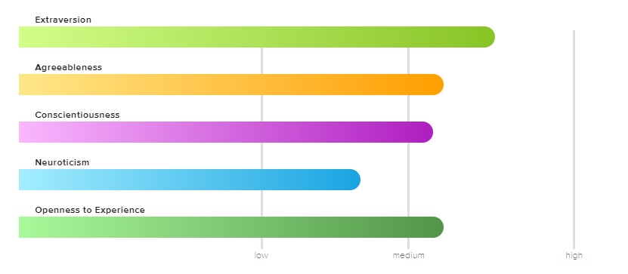

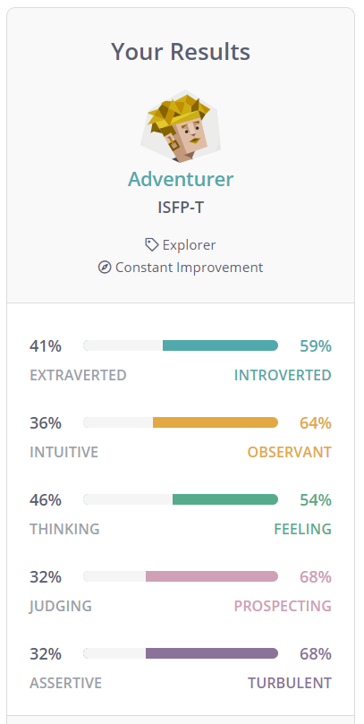

.

**James Eland**

Name: James Philip Eland

Student Number: s3909450

Background:

I am an Australian, my father is English and mother is of South African descent.

I went to Chipping Norton Public School from 2008-2014 and Holsworthy High School 2015-2020.

I speak fluent English and a bit of Japanese. I have done GKR Karate for 12 years and am the 2012 national Karate Champion. I also can swim very well; over the years I have qualified to zone swimming for 7 years straight and attended regionals once.

Hobbies:

I enjoy playing video games but favor the PS4 games over the others. I enjoy watching anime and watch YouTube particularly about rubix cubes and gaming

IT Interest:

I enjoy learning about what IT can do and achieve and wish to learn more about it to help me in the future if I decide to learn about animation or game development.

IT Experience:

I do not have any industry experience as I have recently finish school.

Test results:

I believe knowing these rest results can help me understand the dynamics of the group and shows how much leadership and self-drive I will need to show to achieve the groups goals.

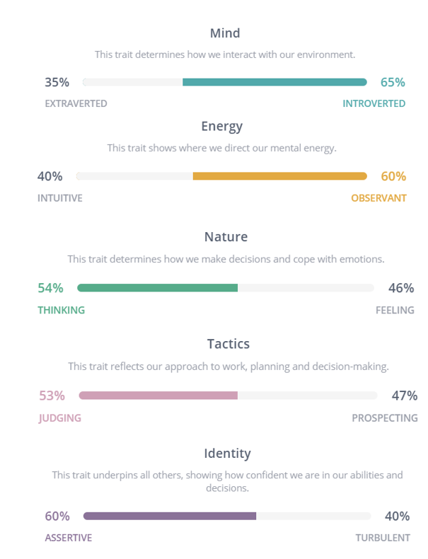

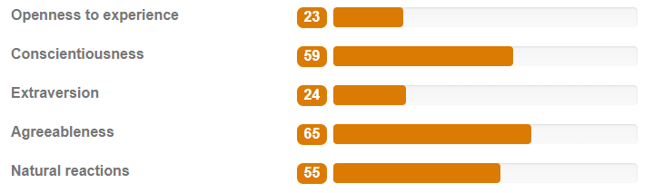

**Jonathan Hazell**

Name: Jonathan Hazell

Student Number: s3908219

Background:

I am from Chicago Illinois but have spent a large amount of time in Houston Texas, where I lived and worked and my two sons where born.

I lived in a lot of Countries growing up, due to my dad job as an Engineer. My education to date, is 3 years at the University of Texas but had to drop out due to work and family obligations.

One fact, I was a commercial pilot and have logged about 15000 hours in the air.

Hobbies:

I am an ice hockey fan both watch and play and love to read.

IT Interest:

I have always been interested in how thing work and mechanical ideas. My Interest in IT started when I was about 12, when I visited my father’s office in San Francisco, and he showed me the computer department. The mainframes where fascinating. Throw in a few movies, a Commodore 64 and I was plugged into the future. I still remember the first time I used the internet, the old-fashioned way, putting the handset of your rotary phone in the modem cradle and dialing into a Usenet site. How times have changed.

IT Experience:

My IT experience, is 25 years as a Unix/Linux systems administrator, looking after large-scale Unix/ Linux systems, webservers, e-mail servers Network file servers etc. Worked at IBM and Texas Instruments in Texas, and AT&T in Chicago.

Test Results:

In my opinion I am not a believer in these kinds of personality test. I believe the results are greatly influenced by how my mood is for that day. If I am in a good mood, bad mood, aggressive. But overall, I think the best way for the team to understand me and know how I work is to talk with me and lay out team expectations

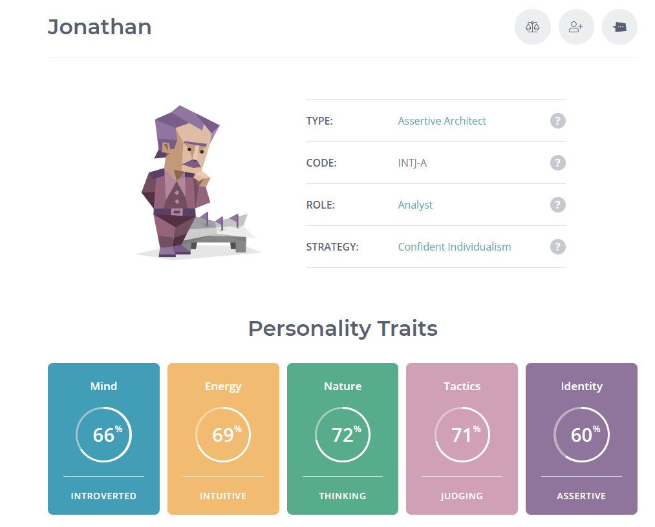

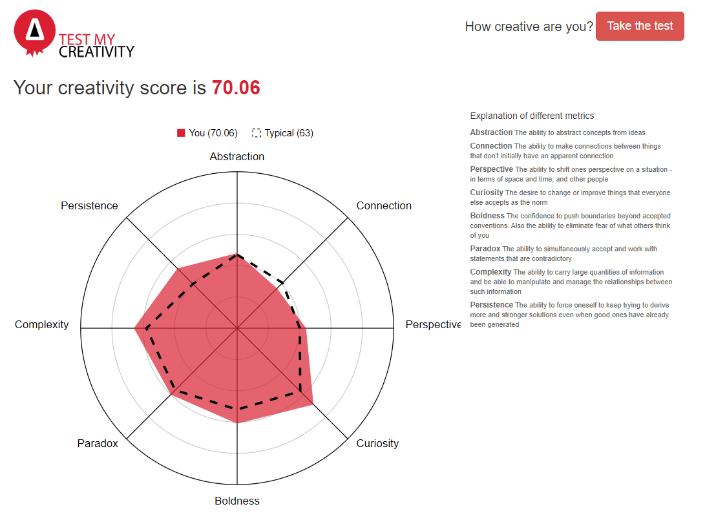

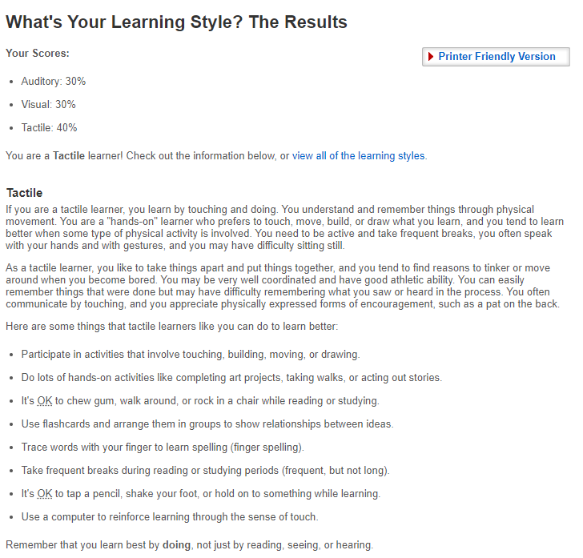

**James Parker**

Name: James Parker

Student Number: s3905759

Background:

I come from a background of sales and marketing, specialising in social media influencer marketing. This job revolves around my main hobby which is bodybuilding

Hobbies:

Bodybuilding

IT Interest:

The interesting aspect in IT that has caught my attention is it made me realize how important IT is to the future and the development of the society. I believe that the advancement of IT and technology will be the prerequisite for the further advancement of technology and knowledge. This is the reason I wish to partake and contribute to this.

IT Experience:

My experience in IT is just beginning with this degree, as my only prior experience was in high school to a small degree.

Test Results: I am fairly neutral regarding this but the group may note my learning language test results as it shows how I retain information best.

Myer Briggs - ENFJ

Learning Language;

- Auditory: 30%

- Visual: 40%

- Tactile: 30%

Big 5 Factors;

Extraversion - 90

Neuroticism – 94

Agreeableness - 83

Conscientiousness - 62

Intellect – 46

**Stefan Siotos**

Name: Stefan Siotos

Student Number: s3894025

Background:

My father is a first-generation immigrant whose parents came from Greece and Australia, and my mother is Australian I have a pretty standard Australian culture at home with both parents only speaking English.

My education is year 12 VCE at Bellarine secondary college and I enrolled into Engineering course in Deakin and completed the first year but it did not interest me. I later changed courses and completed the first year of Commerce at Deakin University as well.

On the right, is my beloved Denvor, a German short hair pointer.

Hobbies:

My hobby is spending time with my Devor. His favorite hobby is chasing frisbees which is perfect for me as I play disc golf casually on weekends so when I am practicing, I don’t have to go and pick up my disc because Denver brings them back to me

IT Interest:

My interest in IT started in 2004 when I first playing RuneScape, I played for many years on and off. Although a video game is what first peaked my interest in computers and IT it has continued to grow, recently the inspiration of my interest in IT has been from the lex fridman podcast https://www.youtube.com/user/lexfridman I am interested in all areas of IT but lately been more focused on Machine Learning and AI.

IT Experience:

My It experience has been in a recreational setting as well as a professional. My recreational Experience ranges from hobbies such as Arduinos and setting up servers for video games I.e (Minecraft) and my professional experience ranges from helping vet new software for the law firm that I was working at and acting as a first point of contact for IT support.

Test Results:

This will help the group realize I tend to stress and my emotions become turbulent. They will need to keep this in mind and keep my emotional levels in check to ensure I am calm and thinking straight. This will help me and them achieve our united goals.

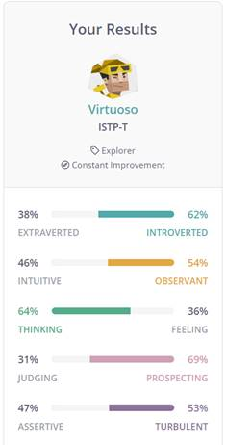

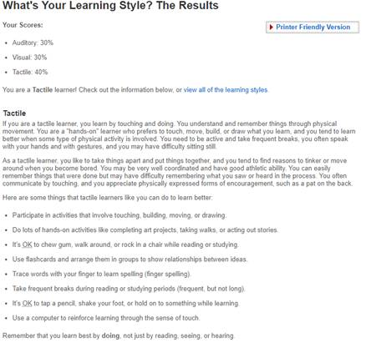

**Jordan Uhe**

Name: Jordan Uhe

Student Number: s3907253

Background:

Hello, I am Jordan Uhe, I was born in Traralgon Australia (about 2hrs east of Melbourne) and I am 18 years old (as of 2021), my family has German, Swiss and English roots, with my ancestors migrating to Australia in the early 1900s. Although that is where my family comes from, I have little connection with those cultures apart from some of my relatives still living there. I have graduated from Lavalla Catholic College in Traralgon in 2020 earning myself a VCE certificate and am currently working towards a Bachelor of Information Technology at RMIT.

Hobbies:

I am an active member of the Traralgon Tennis Club playing every Thursday night and I have done so for over 5 years, sadly not winning any finals; I have also helped the club out with working bees and setting up for tennis tournaments. Apart from tennis I used to play soccer for Olympian’s soccer club, and with them I have been a part of 3 grand final winning teams, sadly I am not currently playing with them because work and study has taken up too much of my time.

IT Interest:

My Interest in IT was sparked by my father who brought home 3 old computers from work as a Christmas gift for me and my brothers. Being given a computer with nothing on it led me to playing the default games loaded on it (pinball and solitaire) but there is only so much of those games you can play without being bored. This led me to messing around downloading stuff from the internet, and eventually getting a virus, this virus made my poor computer unusable, and I was too embarrassed to confess what I had done to my parents, so I learned how to reimage a computer, and that’s where my love for computers and problem solving started

IT Experience:

As I am fresh out of high school, I do not have any professional IT experience. My experience involves me exploring with the computer my father gave me and researching on different capabilities computers can do.

**Ideal Job Analysis Matrix**

To view in-depth analysis according to the matrix, please click on the links in the boxes below

|  |  |  |  |  |  |  |
| --- | --- | --- | --- | --- | --- | --- |
| VS | Don Vu | James Eland | James Parker | Johnathan Hazell | Stefan Siotos | Jordan uhe |
| Don Vu |  |  |  |  |  |  |
| James Eland | Analysis 1 |  |  |  |  |  |
| James Parker | Analysis 2 | Analysis 6 |  |  |  |  |
| Jonathan Hazell | Analysis 3 | Analysis 7 | Analysis 10 |  |  |  |
| Stefan Siotos | Analysis 4 | Analysis 8 | Analysis 11 | Analysis 13 |  |  |
| Jordan uhe | Analysis 5 | Analysis 9 | Analysis 12 | Analysis 14 | Analysis 15 |  |

To view members ideal job, please click on the link below

* Don Vu’s Ideal Job
* James Eland’s Ideal Job
* James Parker’s Ideal Job
* Jonathan Hazell’s Ideal Job
* Stefan Siotos’s Ideal Job
* Jordan Uhe’s Ideal Job

# Analysis 1

What common elements are there, if any?

Both roles work closely with SLA and ITIL procedures. Both looks at resolution capabilities but at different levels. The expectation of the two roles is similar yet different at the same time.

What differentiates each position from the others, if anything?

Don’s ideal job classifies to be a senior management role where there are more responsibilities and people management as well as high tier escalation points. Don’s Operations manager role is the point of escalation from Tier 1 and Tier 2.

Compared to James role, as an Analyst he is responsible for Tier 1 and Tier 2 as well as project work. James’s role has a broader coverage of the business and tends to resolve issues internally; whereas Don’s role is to escalated the issue to relevant vendors and work with them to resolve the issue as it cannot be resolved internally.

# Analysis 2

What common elements are there, if any?

Both Don and James ideal role belong to the management cluster. They are usually appointed to people with 10 plus years of experience in management. Not only are they expected to fulfil their own SLA but they need to manage their teams and external vendors to completed set projects and tasks.

What differentiates each position from the others, if anything?

Don’s role includes managing service providers and becoming an escalation point for Tier 1 and Tier 2. Overall, still working closely with the floor to achieve and resolve issues. James role however, looks at innovation and ways to improve the business in regards to IT.

# Analysis 3

What common elements are there, if any?

Between Jonathan and Don’s ideal job there isn’t much of a common element. Overall, the skills and experience are required in both roles. There is a common ground in all recent IT positions whether it be managerial or administrator; the need to understand and practice ITIL is expected as a base line knowledge for anyone entering the industry.

What differentiates each position from the others, if anything?

The most obvious differentiation that is evident between the two positions is Don’s role is a managerial role and Jonathan’s role is an Administrator role. Managerial role is more of a middle man between escalation points internally or external vendors. Whereas an Administrator role will resolve the issue internally or be the first point of escalation

# Analysis 4

What common elements are there, if any?

Common element between the two positions is they both require to engage with the user. They both work with the user in a specialized way to achieve the desired outcome. Although with Stefan role it is a specialist role but the same concept can be applied to Don’s managerial role as well.

What differentiates each position from the others, if anything?

As mentioned before Stefan role is a very specific and specialist role that cannot be taught or trained anywhere else. Its very specific focus on supporting the scientific team to achieve their outcome. Whereas Don’s role focuses on high level resolution with external vendors to achieve the best results for the business.

# Analysis 5

What common elements are there, if any?

Both of the roles fit the mangers profile. Both looks at issues that require reevaluation, designing and implementing new solutions to achieve an outcome.

What differentiates each position from the others, if anything?

The thing that differentiates the two positions is that one focuses on cloud solution and other focuses on a broader aspect of IT. It can be infrastructure, cloud or anything that Tier 1 and 2 can escalate up to the operations manager and he will need to liase with the specialist to accommodate the solution.

# Analysis 6

What common elements are there, if any?

There is not much common in these two jobs in comparison. They are on opposite sides of the spectrum and as such are difficult to compare between an analysist role and a project manager role.

What differentiates each position from the others, if anything?

One is focus on Tier 1 and 2 ground floor issues and the other looks at projects. These two roles

# Analysis 7

What common elements are there, if any?

The common elements in these two jobs from Jaems and Jonathan is that they both are Tier 1 and 2 based. They focus on issues that users experience on the floor and hope to resolve it within an agreed time frame.

What differentiates each position from the others, if anything?

The difference between the two position purely resides in the nature of the role. One focuses on Linux based systems with Tier 1 and 2 support. Other focuses on infrastructures and CISCO devices.

# Analysis 8

What common elements are there, if any?

Both roles look at supporting end users on the floor. It looks at issues that may arise that will affect the users and work out a solution for the users.

What differentiates each position from the others, if anything?

In Stefan’s ideal job, it shows that his role requires him to develop additional software and application to cater for the needs of his users. Whereas James role looks at supporting and escalation points.

# Analysis 9

What common elements are there, if any?

Between the two roles, there are very little to no common elements between the two.

What differentiates each position from the others, if anything?

Once again, the two roles are different as one is a role is an administrator role and the other is an operations manager role. Not only do the scope of the position are incomparable but the nature of the work is difficult to compare.

# Analysis 10

What common elements are there, if any?

Minimal common element between the two position.

What differentiates each position from the others, if anything?

James’s role is a Senior Project Manger as his role focuses on project development, monetary budgeting, commissioning, designing etc.…whereas Jonathan role is an Administrator role that is design to respond to issues from end users and prevent issues from occurring by monitoring and updating systems.

# Analysis 11

What common elements are there, if any?

The common elements in these two roles although they are on different levels, is that they both develop and implement solutions for the end user.

What differentiates each position from the others, if anything?

Stefan’s role is a very unique and specialized role, James however focuses on project development and budgeting. The two positions focus on different aspect of the IT life, Project needs to be designed and completed and used before Stefans role can be placed in to support and uphold the system.

# Analysis 12

What common elements are there, if any?

Common element between the two roles is that they both are in the senior management area. They both plan, design, implement and manage resources and budget to achieve the solution

What differentiates each position from the others, if anything?

The only different element between the two is that one is a cloud based service provider and the other is a general project manager.

# Analysis 13

What common elements are there, if any?

Common elements between the two roles here is that both roles work very closely to the end user. They are expected to develop and assist their end users use the system to the best potential.

What differentiates each position from the others, if anything?

Both roles are very specialized and unique in their fields. Stefan role will be very unique and incomparable to others as it’s a specialist role that you will not see in other IT fields.

# Analysis 14

What common elements are there, if any?

The two positions are very different from one another.

What differentiates each position from the others, if anything?

Jonathan’s role works off the ground with the end user. His role requires him to resolve user issues, monitor systems and perform upgrades/patch work etc. Whereas Jordan’s role is a Clouds operations manager where planning and development is the only aspect his role will focus on.

# Analysis 15

What common elements are there, if any?

No common elements evident.

What differentiates each position from the others, if anything?

The different elements between the two roles here is one is a specific specialize role that incorporates troubleshooting, developing and implementing. Whereas Jordan’s role is a Clouds operations manager where planning and development is the only aspect his role will focus on.

# How similar or different are your career plans across the group?

Overall, the groups career plans is very diverse, we have members whom are aiming for administrator roles, specialist roles, managerial roles and even senior management roles. The group dynamic is so complex as many of the roles are in different specialization fields within IT. There are similar elements in some members but at the end of the day the final destination goal is to achieve our desired jobs.

**Ideal Job Page**

# Don Vu’s Ideal Job

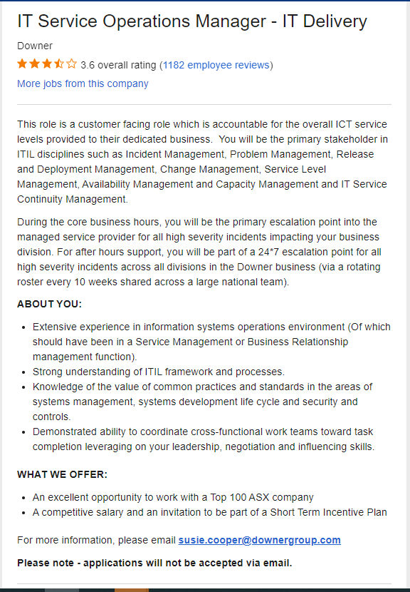

# James Eland’s Ideal Job

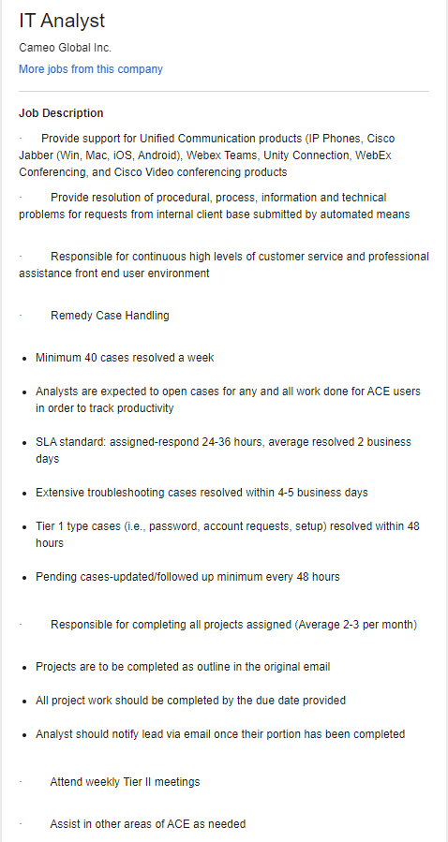

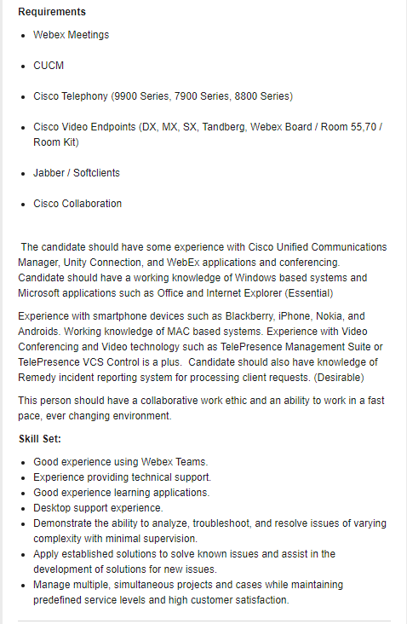

# James Parker’s Ideal Job

# Johnathan Hazell’s Ideal Job



# Stefan Siotos’s Ideal Job

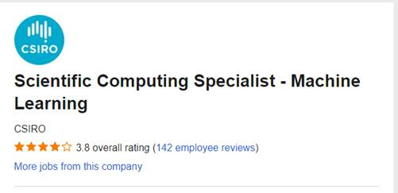

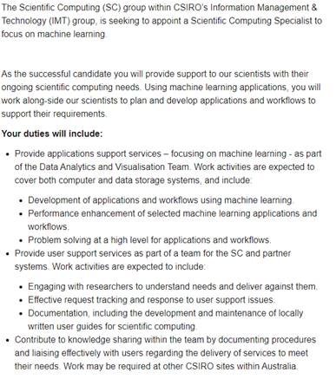

# Jordan Uhe’s Ideal Job

Cloud Operations Manager

• A description of the position

This position involves managing cloud services infrastructure and integrating it into existing ICT services. It also involves making plans on how cloud systems would be operating, designs and implemented as well as making sure the servers follow security regulations.

There is also some troubleshooting of hybrid cloud environments which can be mission critical.

I have always found Complex systems fun to try and simplify and fix, which means a mess of cloud servers would be a challenge which I might find fun. I aspire to be a manager of a department or at least high in the chain of command, so a manager position is appealing.

• skills, qualifications, and experience required for the position.

-Experience and skills in cloud operations, server Management, user privileges, computer use monitoring, and systems automation.

-Excellent communication and negotiation skills, with the ability to simplify complex ideas so that laymen can understand

-Ability to think about and imagine different possibilities and transform them into a reality which can be produced by other people

-The ability to work around strict conditions such as limited resources

-Able to negotiate and communicate effectively with clients and contractors

Industry Data

General skills highlighted yellow

James Eland – IT Analyst – Rank 5

Skills:

* Good experience using WebEx Teams. - No rank
* Experience providing technical support. . - No rank
* Good experience learning applications. . - No rank
* Desktop support experience. . - No rank
* Demonstrate the ability to analyze, troubleshoot, and resolve issues of varying complexity with minimal supervision.  Rank – 2, 7.
* Apply established solutions to solve known issues and assist in the development of solutions for new issues. Rank - 2
* Manage multiple, simultaneous projects and cases while maintaining predefined service levels and high customer satisfaction. Rank – 13.

Don VU – IT Service Operations Manager – Rank 192

Skills:

* Extensive experience in information systems operations environment. - No rank
* Strong understanding of ITIL framework and processes. - No rank
* Knowledge of the value of common practices and standards in the areas of systems management, systems development life cycle and security controls. . - No rank
* Demonstrated ability to coordinate cross-functional work teams toward task completion leveraging on your leadership, negotiation and influence skills. – Rank 5, 11

James Parker – Senior IT Project Manager – rank 67

Skills –

* Communication skills – rank 1
* Leadership skills - rank 11
* IT experience – ranked 16 in general

Jonathon hazel – System Administrator (Linux) – Rank 8.

Skills:

* Day to Day management of Linux environments – Rank 7
* Linux Management: RedHat Enterprise Linux - Rank 7
* Networking: Virtual Network Infrastructure - rank 52
* VMWare Virtualization technologies - rank 141
* Australian citizen
* Practical experience in the configuration and management of Administration and monitoring ICT systems
* Cyber security toolsets
* Development and maintenance of Standard Operating Procedures and ITIL practices.

Stefan Siotos – Scientific Computing Specialist – Machine Learning Role – No rank

Skills:

* Experience with programming languages such as Python, R, JavaScript, MATLAB, Fortran, C, and C++. – rank 2, 12, 22, 166, 101,
* Experience using machine learning applications Computer vision, Natural language or a tradition tabular data-based ML algorithms. – no rank
* A tertiary degree in either science, engineering, computer science, information technology or a relevant field. – no rank

The three highest ranked IT skills that are not in our skill set are SQL(rank 1), Microsoft Windows(rank 3) And Microsoft c#(rank 5)

And the three highest ranked general skills are Communication skills(rank 1), Organisational skills(rank 3) and Writing(rank 4).

Having looked at the burning glass data my ideal job hasn’t changed, this is because even though my ideal job may not be the most in demand, I would be happy doing other things until the opportunity arose itself. So I don’t see a point in focusing on something I am less interested in when a lot of the skills are transferrable anyway for example going from a PHP developer to a web developer a lot of the skills and networking you will do in both jobs will be similar.

Jordan Uhe – Cloud operations manager

Skills:

* Experience and skills in cloud operations, server Management, user privileges, computer use monitoring, and systems automation.(rank 158
* Excellent communication and negotiation skills, with the ability to simplify complex ideas so that laymen can understand (rank 1)
* Ability to think about and imagine different possibilities and transform them into a reality which can be produced by other people (rank 4)
* The ability to work around strict conditions such as limited resources (rank 13, rank 19)
* Able to negotiate and communicate effectively with clients and contractors (rank 1)

The three highest ranked IT skills that are not in our skill set are SQL(rank 1), Microsoft Windows (rank 3) And Microsoft c# (rank 5)

And the three highest ranked general skills are organisational skills (rank 3), Writing(rank 4) and Planning (rank 7)

Having looked at the burning glass data my ideal job hasn’t changed, this is because even though my ideal job may not be the most in demand, I would be happy doing other things until the opportunity arose itself. So I don’t see a point in focusing on something I am less interested in when a lot of the skills are transferrable anyway for example going from a PHP developer to a web developer a lot of the skills and networking you will do in both jobs will be similar.

IT Work

The work of IT professionals is varied within the industry ranging from support roles to project management. To better understand what the day to day life of an IT professional looks like, I have conducted an interview with a relevant professional who works within the IT Project Management space. For this interview, Ata Sohrabi a Digital IT Project Manager at EHPlabs offered insight into his usual tasks and some of the challenges of his role.

Ata is in charge of all Digital projects at EHPlabs and the main priority of his role is end to end execution of digital products. These products include but are not limited to mobile apps, ecommerce solutions, ad hoc solutions and legacy system integrations and migration. He is also in charge of scoping out fresh projects that will assist the business’ growth and provide solutions to pain points. Once he identifies a pain point for the business he will map out a solution to the problem and this can take many forms. A recent example of this would be the migration of the brand’s ecommerce website from a tired legacy system, to an upgraded one which was Shopify in this case. He is not as involved in the development of these solutions, but rather the planning and execution of them. After being in the Industry for some years he has found that Project Management suits him better as opposed to the development of apps and programs directly.

Within Ata’s role, he interacts with the Senior Management of the Company and his two main team colleagues. His colleagues often work beside him everyday in constant communication as they work together to develop their solutions. Every week he has a meeting with his upline to discuss solutions that he has invented or to check in on the progress of current projects. Rarely, but when required, he will have a meeting with the CEO and CFO of his organization to get permission or funding for projects granted. He does not have any direct contact with consumers of the brand but his work does directly affect the experience of customers everyday.

Ata spends the majority of his time testing the various solutions that he has developed. A large chunk of this time revolves around creating reports of what he made with his team and planning ahead. There also is a fair amount of backlog grooming involved in this part of the role. When testing and creating reports isn’t taking his time then the next largest use of his time each week is planning. This includes the planning of future projects or the prioritisation/de-prioritization of features within current applications.

The most challenging part of the role is planning and future projections. With having no in house developers, Ata is forced to work with third party teams who are often in Europe or the US. This means that he doesn’t have much control over his project timelines, being at the mercy of these third party teams to deliver on time. This gets even trickier when one team gets delayed as it forces any other teams who are developing pieces of the project to stop their progress. This can push projects back weeks and sometimes even months. Ensuring that he finds the right team for the project is also a challenge each time a new solution is invented and development is needed. For his most recent project, Ata migrated EHPlabs’ legacy website onto a new platform. This entailed the migration and following maintenance of the database for the website along with some cloud engineering to make sure the development is up to standards. Although it is not part of his day to day role, he also personally did some coding and data management in this process too.

Ata’s role within EHPlabs’ is just one example of all the varied roles that the IT industry offers. Whether in Digital Project Management or development, it is clear that every role plays an important role and that a diverse interdependent team with unique specializations is required for an effective IT team.

Raw Transcript

1. Digital project manager at EHP Holdings, what he does is end to end execution of a range of digital products. They vary from mobile apps to e comm solutions and ad hoc solutions, legacy integrations and systems we already have in place. In charge of scoping out fresh projects. Identify pain points and how new projects will alleviate pain points. Sometimes end users are customers of the brand that we solve pain points for. What is it and how do we solve those problems? In EHP he holds many hats not just IT but also product ideas.
2. The IT industry is a very broad industry that can start from infrastructure, you can work in networking or IT. You can work in databases or programming. A very wide range of skills all fall under IT. His IT experience comes from software dev and programming. He has a degree in electric engineering and IT. Found coding is not his core strength, not passionate about it. Found he is better at project managing for apps and development. Worked closely with business development analysts so he can direct developers in what they need to create and make solutions.
3. Sometimes he has to do some IT support role (system admin role) he also updates the website too. Or he will create an email too. Design from a product (mobile app) ready and so he will roll up his sleeves and do some of the design himself. Does some wireframing also. Black and white
4. He interacts with developers and the people who code the solutions. Make sure things are running on time and that they are on track. Sets goals for each 2 weeks of things that must be completed. UX/UI designers in terms of mobile app design.s Works with his colleague to plan out a roadmap for development and how they achieve the bigger picture together. Works with the coaching and CEX team the frontline of B2C. He gives the solutions to fix customers problems also and sometimes uplines it to the devs.
5. Does Not develop for clients or investors so much. Creates and interacts with the CEO and CFO to develop what they need. Have weekly project update calls with his upline to highlight successes and any problems they have. Also to highlight new project ideas with his upline and CEO/CFO are later on. We identify a problem for customers and then come up with a solution and get backing from the team to take it to the next step.
6. Sometimes testing products takes most of the time. Big chunk of it can be creating reports (what we made) or planning ahead. Backlog grooming. Priorities change time to time and checking in on features to be prioritised or deprioritized. Sometimes planning takes the most time
7. Planning and projections for the future seem to be the most challenging. We don't have much in house developers and so more work on his plate. He also has less control over projects as they are 3rd party made so has to work by their timelines. Sometimes a delay from one part will affect all other parts. Sometimes there is no choice and a delay must be endured. 90 grand is standard for app development
8. One of the things that he did, we were on a legacy e com platform. The project was to migrate to a newer platform. Migrate the whole database and then maintain it. He also created a solution to the old legacy system. Was working with cloud engineering and making sure it is up to our standards. Coding of new programs and back end logic and data management.

**IT Technologies**

**Autonomous vehicles**

There are currently around 40 companies working on autonomous vehicles including automotive heavyweights like Toyota, Audi and Honda as well as tech heavyweights like Tesla, Waymo and Comma. Ai , for the sake of simplicity we will be focusing on only two companies as who are taking different approaches to self-driving vehicles and are at different steps along the way. The Society of Automotive Engineers have released a 6 Level system for defining what level of automation a vehicle has. (SAE International Releases Updated Visual Chart for Its “Levels of Driving Automation” Standard for Self-Driving Vehicles, 2021) The levels are represented as a level 0 which is a vehicle that has 0 self-driving features and the driver is still in control of the vehicle and a level 5 is represented by human driving being completely eliminated and do not require human attention.

We will start by talking about Tesla a company that many know as the “King” of electric and self-driving vehicles. In October of 2016 Tesla released an article stating that all of the cares produced will no have the hardware to enable level 5 autonomy although the software was not quite ready. (All Tesla Cars Being Produced Now Have Full Self-Driving Hardware, 2016) In the article they state that they will further calibrate their self-driving system by using millions of miles of real-world driving experience taken from the users. Currently they are at level 4 on the SAE Rating system however Elon Musk CEO of Tesla Motors believes that they are very close to level five autonomy and believed that they would have the basic functionality of level 5 autonomy by the end of 2020 and that there are no fundamental challenges left of reaching that level (Elon Musk 2020, 1:00). Some of the Hardware developments that were required for level 5 autonomy were the development and improvement of Tensor processing units (TPU) which are designed to make neural net training and predictions a magnitude faster. The way Autonomous vehicles use deep neural Networks (dnn) is by feeding the neural network information from various sensors which are fed through a neural network to make sense of the environment and then create a decision on how the car should behave.

The second company I will be talking about is Waymo which began as googles self-driving car project in 2009 its mission statement is to make it safe and easy for people and things to get where they’re going. Currently waymo believes that they are at level 4 autonomy meaning that no human driver is necessary in there defined operational conditions (Waymo 2021) . Waymo works by first going into a new area or city and maps the area including details like stop signs and cross walks and then instead of relying on data such as a gps it uses its detailed maps and sensor data to determine its current location. Waymo currently has two services a Ride Hailing Service and a Truck service. Some of the Sensors that Waymo uses to feed data to its custom neural networks are Lidar, Cameras and radar. As well as many backup systems a secondary computer and backup collision detection systems in case the primary systems fail. One of the problems that waymo currently has is that they rely on their detailed maps so as you start mapping bigger areas this turns into a large challenge. Waymo are also using a TPU after partnering with google brain to train their Machine learning algorithms.

The development of autonomous vehicles will has the potential to have large impacts on many industries and the general public. In a study by the university of Michigan they believe that the number of vehicles owned per household could reduce up to 43 % (SCHOETTLE and SIVAK, 2015) This reduction in vehicles could have large impacts on the automotive industry as the number of vehicles needed to service the population would be reduced due to return home features of self-driving vehicles. Another potential impact is on industries like mining where autonomous vehicles (avs) can operate in areas that are high risk by taking out the drivers which will increase worker safety and productivity this however also will displace many people who work in industries that rely on someone controlling a vehicle, This will also effect industries like farming, truck driving and ride sharing services or taxi companies that can rely on AVs to do the job instead of human operators. The people who will be most effected are the people who work in these industries as the US department of commerce believes that 15.5 million U.S workers are employed in occupations that could be affected by the introduction of AVs (The Employment Impact of Autonomous Vehicles, 2017) there are also some new jobs being created from the development of AVs, an example is at Waymo when one of their AVs comes up to a situation that it doesn’t know how to deal with it will send the information out to a human who then makes the decision on how the car should proceed this happens when an unusual occurrence happens such as road work or a police officer directing traffic.

As AVs continue to develop and become more available my life and the life of my friends and family will be affected in a multitude of ways. One of the ways it will affect me is by the large displacement of the work force who will lose their jobs to AVs these people will need to find new jobs and careers and will increase the amount of competition for various careers, a number of new jobs will also be available which could impact which career I end up in the future. Another positive way it could affect me and my friends is the possibility of longer commutes to work being less time consuming as you will be able to do other things while you drive, such as catching up on sleep or reading. This will make jobs in areas outside of where I currently deem an acceptable commute to become more attractive opening up the number of jobs I can target.

Some of my Family members are elderly so AVs could change their lives dramatically as they are losing confidence driving some of them are stuck to public transport and being from a rural town that dramatically increases the times that they can travel to the places they want to go and will reduce the time that it takes them to travel to places. As with AVs they may not even need to have a licence to be able to drive a car. This will also impact people with disabilities who aren’t able to drive and have to rely on taxis or public transport, while I was working one day a lady came in who could no longer drive and she had to cancel her appoint 2 times due to no taxis being available nearby to take her to her appointment, I’m sure if you asked her what she thought about a car that she could own that would be able to drive itself she would be over the moon.

**Cloud Computing**

Cloud computing is one of the buzz words in today technical jargon, as indeed it should be, as the capabilities of cloud computing are endless. Most people think that cloud computing is a relativity new concept dating back the last 10 to 15 years, but this is not the case. Let us take a brief look at the history of cloud computing. Since the 1950s, due to the prohibitive costs of mainframes and computers organizations have been using a more complex and everchanging ideas to process their data. To do this they implemented the idea of time sharing, where several users could access the mainframe from there dumb terminals (terminals with no processing power) and utilizing the maximum efficiency of the mainframe. Sharing the power of the mainframe by many remote users was the foundation of the cloud computing. The idea of sharing resources continued throughout the fifties until the 60’s when an American computer scientist named J.C.R. Licklider came up with an idea for an interconnected system of computers. The idea of interconnected computer systems was taken up by a division of the American military called The Defence Advanced Research Projects Agency.

DARPA was asked by the US Government to create a network of connected computers that could talk to each other and keep government departments connected in the case of nuclear war. This revolutionary idea helped Bob Taylor and Larry Roberts develop something known as ARPANET (Advanced Research Projects Agency Network). This was mainly a series of connected computers located at the department of defence and several Universities such as Cal Tech and Berkley. The internet or ARPA net grew into a worldwide network of computers spanning the globe, giving everyone cheap access to processing power and Web. This has led to the development of the cloud and the services it provides. There are three types of cloud types, Public Cloud which is owned and managed by a combination of businesses, universities, government organizations and their services are shared among multiple customers. Private Cloud, where the cloud service is not shared with any other organization and Hybrid cloud which refers to a mixed computing, storage, and services environment comprised of on-premises infrastructure, private cloud services, and a public cloud. There are several major Cloud providers today, Amazon Web Services, Microsoft Azure and Google Cloud Platform to name the biggest of the cloud companies. In this article will discuss AWS or Amazon Web Services, since it is not only the biggest but also considered to be the forerunner of cloud services. So, what does this all mean for businesses, organizations in general. Cloud providers such as AWS basically provide on demand delivery of IT resources a service in that they basically provide the hardware, software, data storage, databases and networking to companies or institutions to use for a price, of (charged as per instance) when you use the services.

This in turn means that companies do not have to buy physical data centres and servers, networking, data storage, data processing, computing power and software licences. Nor do they have to worry about the upkeep of these systems or hiring people with technical expertise, AWS can provide all this and more as a complex ever evolving infrastructure in 3 major services categories, infrastructure as a service (IaaS), platform as a service (PaaS) and packaged software as a service (SaaS). We will touch briefly on each one as well as the other services Amazon offers.Infrastructure as a service (IaaS), is basically what it says, you avoid the expense and complexity of buying and managing your own physical servers and other data centre infrastructure. Each resource is offered as a separate service component, and you only need to rent a particular one for as long as you need it. In addition, it quickly scales up or down rapidly meeting your organizations needs and you only pay for what you need. Its basically the foundation for the other service. Platform-as-a-service (PaaS) is a service that delivers a platform to clients, enabling them to develop, run, and manage business applications without the need to build and maintain the infrastructure such software development processes typically require. Software as a Service (SaaS) is a cloud service where instead of downloading software to your desktop or business network to run and update, you instead access a wide range of software applications, business application, communication applications via an internet. SaaS offers lower upfront costs than traditional software downloads and installation, making them more available to a wider range of businesses, and the advantages this brings. Since it runs through a browser you do not have to worry about hardware and software compatibility, patching, upgrades and maintenance. AWS Elastic Beanstalk offering is an easy-to-use service for you to deploy web applications and services developed with Java, .NET, PHP, Python, Ruby, on familiar webservers servers such as Apache and Nginx.

You can simply upload your code from a Git repository and Elastic Beanstalk automatically handles the deployment, provisioning, load balancing, auto-scaling to application health monitoring. At the same time, you retain full control over the AWS resources powering your application. These are just some of the services AWS offers, there are many more, block chain, compute, web hosting, IOT (internet of things), databases, game development, Quantum Computing and Technologies. This is a rapidly developing field, with many advances being developed every day. As you can see cloud services depends a lot on network infrastructure, bandwidth and download and upload speeds are critical. Advances in wireless such as 5G and greater are critical to cloud services, as are advances in the speeds of the physical servers in the Data Centres that so much of this relies on. The faster the servers and support equipment is the faster everything will work. The processing power of Quantum Computers being developed by Google and others well offer great leaps forward in the quality and speed of service. The advances made in artificial intelligence will play a major role in creating new algorithms that can improve on cloud throughput, load balancing and sequencing. The affects of cloud services are many and will eventually affect all aspects of business and industry. It is reshaping technology. Companies no longer have to purchase expensive hardware or maintain in house systems they can simply buy time on AWS, they no longer have the cost and overhead of application development, it can all be deployed in the cloud. Companies can move so much of there services online, banks being a prime example. I use several online banks, that have no physical stores. Development and design of manufactured items can be moved to the cloud using Cloud compute and machine learning as can supply chain.

Media, human resources and government departments and functions can all be replaced by cloud services. This is going to affect people’s jobs, companies are not going to need as many IT staff, companies that can move a lot or all their services to the cloud and online will downsize and reduce physical staff, less office space to be leased, assembly line workers can be replaced by robots run from the cloud, driverless cars and delivery trucks. Cloud companies such as Sales Force or SAP can take over all a company’s services such as accounting, pay role and many others. On the other end of the spectrum researchers, engineers, scientists will be in demand developing the next cutting-edge technology as cloud services continue changing and evolving. A simple example of how cloud architecture can change a whole business model is Amazon online shopping. It not really a matter of what cloud technologies will change, its more a matter of what it will not change. The cloud affects my life in multiple ways, just about everything I do involves the cloud in some way or another. I am writing this article on Office 360 a cloud-based app, it stored on a cloud server, I am accessing it through a cloud-based web browser. I bank online, I use a cloud-based map to get around, I do all my shopping online, my movies and my music are from a cloud-based service. I administer Linux servers located on a cloud somewhere in the world. Everyone, my friends, colleagues, family all utilize a cloud-based service at some point during the day, we communicate through SMS, WhatsApp, WeChat. The only way to avoid this would be to disconnect from the internet and live in the woods. Even then I am not sure if that is possible. As technology progresses and the internet and cloud services become cheaper and faster and more sophisticated everything will be connected to the cloud and everyone will utilize some form of cloud-based service. It will no longer be a cloud more like a hive mind.

**Blockchain and cryptocurrencies**

**What is BlockChain and Cryptocurrency?**

Block chain and Cryptocurrency are both disruptive technologies that seek to instil more democracy in both the internet and financial world. Block chain technology in its current state of the art is a decentralised and distributed financial ledger built on a peer to peer system that is openly shared and creates an immutable record of transactions that are timestamps. Each of these transactions is called a block. At its current developmental stage financial institutions are utilising it the most. This is due to some important key factors, first of these being its best known associated technology Bitcoin and secondly, the flaws in the traditional financial system that were highlighted during the 2008 financial crisis (Nofer, Gomber, Hinz and Schiereck, 2017). Block chain along with cryptocurrency signals a transitory shift of power from a monarchical system, to a peer to peer system (Pepe, 2018), As stated by Antonopoulos, these technologies represent “a shift from trusting people to trusting math” as faith in human ledgers and institutions is no longer required (Antonopoulos, 2021).

**Positives and Negatives**

The distributed ledger system that BlockChain technology enables, offers both benefits and negatives. When compared to the existing centralised systems, where ledgers require human intervention, the networks of Cryptocurrency do not break down even In the case of some node failures. Essentially the network always has a backup and cannot be switched off. As a result, trust in this technology is raised when an individual no longer has to assess the trustworthiness of the network or its participants. The removal of middle men in this process helps to also further data security as a whole with data being spread over a network not stored in a singular space. As discussed in a recent MIT paper, there is no conceivable method of governance over user’s digital identities that is centralised due to the backlash a move such as this would incur. However Block chain offers the opportunity to award everyone digital identities that are globally recognised and borderless without the need for centralised institutions to store this information. A current example of this system is ShoCard which is a globally verifiable identity that can be trusted by governments and banks alike. However, the platform for ShoCard is built of a public block chain layer, so that no one company is storing this important information while also being encrypted so as to not be tampered with (Shrier, Wu and Pentland, 2016).

In contrast to some of these positives exist some problematic negatives. Block chain, much like money is a neutral resource, it can be used for both positive and negative effects. As discussed by Voshmgir in her 2018 TED talk, we may design a machine that works against us, posing the question of governance over BlockChain. The code that the system is based upon sets the limitations of what is possible, meaning that governance experts must also be involved in the development of this cutting edge technology. Voshmgir insists that the incentives of this new technology must be chosen carefully, recognising that the current bitcoin model is plutocratic, incentivising those who already have wealth in the real world can also dominate cryptocurrency(Voshmgir, 2018). If the anonymity of the technologies associated with crypto technologies are not certain, then back doors could be opened leading to manipulation of these technologies into social scoring systems like those recently implemented in China.

At the moment, BlockChain is still in its infancy, like the internet was during the 90’s, however the promise of this technology is already being seen. (Pepe, 2018) These technologies have not has their desired impact yet as “block chain created a huge ‘pause’ in decision-making as organizations generally appreciate its transformational capability, but were unclear about next steps” as according to Louden Owen, CEO of DLT Labs, a Toronto based block chain development enterprise (Ismail, 2021). As for the future of this technology K.Schlapkohl of IBM predicts that as “Pragmatic governance models will emerge”, Central Banks will take one step closer to embracing this technology (Schlapkohl, 2020).

**Impact of BlockChain Technologies**

BlockChain technology is already making quick ground within core industries in terms of attention and in some cases piloting of test programs. In 2019 Deloitte’s industry report found that 53% of respondents acknowledged that Blockchain has become a critical priority for their business, and 83 percent see worth in Blockchain implementation (Deloitte, 2017).

This adoption of BlockChain will see impacts across multiple industries. One of the most concerned industries would have to be the Financial Industry. Blockchain will implement a new book keeping ledger system that is immutable and verified by the system itself for payments. This will automate the process that is currently performed by banks and auditors (Holotiuk, Pisani and Moormann, 2019). With Blockchain the need for reconciliation or separately stored information will be replaced with a unique single version of the truth, with every piece of information within its ledger being time stamped and assigned an owner. The possible consequences for Financial Institutions will be disastrous if this technology goes mainstream as by nature it is more secure, instant in every case and more private (Aste, Tasca and Di Matteo, 2017).

The implementation of this technology is already being utilised to certify documents and belongings. Even the diamond industry has begun implementing Blockchain to certify their assets authenticity and to provide proof of existence via the timestamp. This proof is immutable and thus generates buyer’s trust.

Perhaps one of the most revolutionary ideas that Blockchain presents is Decentralised Corporations and Governance. In its current form, society is centralised and institutions exist to govern our socio economic communities. Blockchain transfers the ownership of access and sharing from these technology hierarchies into non-hierarchical governance spread to the edges of the network. Decision making will be made across users in the network rather than being handed down and controlled from the centre (Aste, Tasca and Di Matteo, 2017).

**Effect of Blockchain on Daily Life**

The impacts of this technology on daily life will extend past only financial institutions but also into public sectors such as voting and personal identification.

The possibility of a borderless, digital identity is what makes all prior advancements possible. Blockchain technology can securely track digital identities much more efficiently assuring the validity of digital identities. This would mean for myself that my identity used in areas of life such as banking, citizenship and employment will be stored securely within BlockChain. Combined this identity with cryptocurrency, and monetary transfers to international family members would be secure and instant. While also eliminating the need to convert to local currency (Hughes et al., 2019).

The decentralisation of the internet will result in a macro level change in society. With the rise of tech giants such as Facebook and Google, the internet has quickly become more hierarchical than intended. Blockchain offers a change of structure from servers controlled by global corporations to a P2P network. With websites running off multiple nodes, certain websites or the internet itself will no longer be censored by governments or corporations. This will also enhance my personal privacy on the internet, with data being stored and spread across the network rather than all stored in one location (Zarrin, Hao Wen and Babu-Saheer, 2020).

My personal Cloud Storage will also be positively affected with the distribution of data across the network rather than stored in a single server, making my data more secure.

These are just a few examples of where Blockchain and Cryptocurrency will affect my personal day to day life. Blockchain is a revolution within itself for the internet and as such positions itself as one of humanity’s greatest inventions with unlimited real life applications.

**Robots**

**What does it do? (600 words What is the state of the art of this new technology? What can be done now? What is likely to be able to do be done soon (say in the next 3 years)? What technological or other developments make this possible?)**

Robots are becoming more viable and easier to build now than it has been in the past. The current state of robots now, I say it is still in development. We can build and program robots to perform certain actions but not have their own free will. Even in japan they have been using robots to help people in their daily lives for either entertainment or to help perform certain actions. Robots still have a long way to go before they are finished and be able to create a new form of society but yet it is going to be integrated into our lives soon.

Robots are able to do some things that humans can do. For example, walking, grab, sense, tedium, perfect objective recall. Just to name a few. These are just some of the things that robots can do now and some of the actions they can do is significantly better than what humans can do. They have force multipliers, have a better focus and like I said earlier being able to perform a perfect, objective recall. There are even robots who can do our jobs better than us and perform the task at a faster rate with either the same consistency or even a little inconsistency throughout perform certain tasks.

I believe robots will be able to do almost the same number of tasks that humans that does not involve cooking. What robots are doing now is incredible alone but yet when it comes to the next 3 years. They will be able to do more tasks and a better quality of work. The improvement from now to 3 years into the future may not seem that significant but now in our day and age. The fact that robots will be able to do even more things than what they can already do. Having robots being more advanced, they will be more than likely be able to have some sort of more improved AI features that can help identify and solve problems and be more expensive to build.

Forms of technological equipment’s that we have that can build a robot are equipment from electrical engineering, information engineering just to name a few. The technological equipment that is used in all of the fields are advanced enough that can precisely build a robot that can function on its own and make its own decision based on what the robot has been programmed to do. Electrical engineering allows the electrical current to flow throughout the entire build and securely able to boot up, shut down and run actively to make the robot to do what it has to do. Electrical engineers have a major role when it comes to making the robot even possible. Without an electrical engineer, the robot will have no form of electrical current to make the robot unified and able to turn on when needed to. Information engineering allows the robot to be able to gain information, retain said information and act upon the information given. They also create the operating system that the robot needs to be even able to run. Without an information engineer, the robot will not be able to do anything. The robot will just stay still and not comprehend any of the information that anything external tries to give to it.

**What is the likely impact?**

Potential impacts of the development of robots are the required equipment to create the robot. As the equipment are being bought. The price of each part might increase because of how many tests and experiments when researching and building a robot. The project to make a robot is expensive as it is already. The price of parts might increase because of having to buy so many parts and a shortage of parts to build the robot. This is just one potential impact of the development of robots.

One thing that will definitely change is how people will become lazier. If robots become a universal product and is easily accessible. People will want to have these robots to do things for them so that they do not have to do the tasks they do not want to do. This will create a society that will have people being lazy and robots doing tasks that has been given to them that humans should be doing. For example, people might not want to cook after a long day at work and have the robot cook for them. By doing this, it will create a psychological difference between them cooking and getting the satisfaction of it and just being lazy and having someone else do it.

The people that are in the high positions of a company is who I believe will be affected the most. This is because they will be doing so many tasks to complete and might need help from a robot to complete them all. This will allow them to complete all tasks that they need to be done and still have time to spend with friends and family. For example, a CEO of a company will have a lot of tasks to do on a day-to-day basis and might require a robot to help him complete his tasks. The robot could go deliver a package by 10am while the CEO needs to be in a meeting at 10:15am and he will be late if he delivers the package. This will allow busy people to complete more tasks more efficiently and be more productive when doing so.

Having robots might be able to create new jobs and make other current jobs redundant. This is because that robots will be able to do the jobs and do it better with more consistency making some jobs completely redundant and people will lose jobs because of it but yet it will create jobs to help maintain the robots and make sure the robots are up to date and have no errors. Also, people need to build these robots in the first place. For example, when assembling a car. There used to be a lot more people to put all the parts together. Now there are robots that can do all the heavy lifting and not have to injure anyone. This also comes with a job of robot maintenance. By having robots will create new jobs and make current jobs and/or technologies redundant in certain fields

**How will this affect you?**

Having robots in our daily lives can help people do some things in their daily lives. For example, having a robot that can reach and grab objects for people who are unable to grab the desired object. The robot allows people to what they would like to have to then do what they want to do in the first place. By having a robot that can reach out and grab things significantly help people for their daily lives.

Having a robot will definitely help me in my life. It will affect me because it will allow me to have a robot to reach areas that I might be unable to reach, like I said earlier and be able to hold things for me when I have my hands full. I tend to sometimes have my hands busy doing when one but I need to have another object be hanging up in a certain position and by having a robot. It will allow me to do exactly that.

A robot will dramatically change my life. I will definitely become lazier and use the robot to help do things that I normally can do myself. This is because I would use the robot to do the things that I do not want to do and I do the things I want to do. Making me be lazier and have no home ethics to do anything.

Having robots will definitely affect my friends and family. My friends and family would use the robot but not that often which will change their lives and creates some positive and negative habits between all of us. This is because that my friends and family might only want to hang out with me because of the robot and what it does. Yeah, having friends and family spend time with you is great and creates a stronger connection with them but it also can create a negative relationship with friends and family because they could only be with you because of the robot. It really depends on the people and the robot itself

**Project Idea – Eavesdropper**

Overview

*Eavesdropper* is a web based chrome application that allows users to track websites for releases of their most desired items.The program will regularly check the HTML code of a specific website that the user has chosen. You can have *Eavesdropper* check for specific parts of the code so that you do not get a notification every time something that you find irrelevant occurs. The user can have multiple websites and have set intervals to when they want the chrome extension to check and send a notification to you. Some available methods of notification would be text message, email or a pop up on the desktop/laptop. This will allow the user to know immediately when something has changed. This extension will run in the background and will not obstruct the user from their current activity. The task of having to manually keep an eye out for an item's release or price drops is all handled automatically by Eavesdropper from now on.

Motivation

The motivation behind Eavesdropper is to help users that are expecting some sort of update on a website or even multiple websites. These updates could be either a new product release or a price change on a website. In addition, the updates could be an addition to a blog or a new episode of a tv show. But the target audience is consumers who are keeping an eye on prices of items or are awaiting the release of limited edition items. However our program does not need to run out of usefulness there with plans to expand beyond our niche after launch.

In the market of limited edition items today, they are often purchased all by bot programs designed to automatically buy the item when it releases. Their motivation for this is the resale market for profit, not out of passion for the item itself. We wish to give the shopper or true collector a more positive chance of getting items they want for personal reasons, not to make profit.

As stated before, this program will be able to send a notification to either email or your phone so that even if you are away from the computer, you can still be kept updated if the change you are watching happens so that you can take immediate action.

Description

Eavesdropper will ideally be split into two running methods, a chrome extension and an application which would run independently on startup of the computer.

When you open the program either from the taskbar, start menu, icon list or the start file it would open the main menu of the program.

For the program running independently when you turn on the computer, it would run in the background with only a small popup which tells you that it is running. This popup can be disabled however for ease of use. When you open the program for the first time from the start file it will ask for your name, email address and/or your phone number so that the program can alert you when required. Then the program would move to the main menu.

The main menu would include a list of what URL links are currently being monitored and what they are being monitored for, i.e. website update or specific value change. Next to each URL they will be a delete button to remove that specific link as well as an edit button which will allow you to change the options which you have set the website to be monitored with. As well as the URL list there will also be an “ADD” button to select a new website to be monitored. When this button is pressed it would open a screen prompting for the URL. Once you have added the URL, the program would open the website so that the user can visually confirm it is correct and highlight what text or value that they want to be monitored. After you have selected what you want to be monitored, it will ask how regularly the user wants the website to be checked.The user can then select at what intervals the website will be refreshed to check for updates. Any changes will be alerted via the aforementioned notification options.

After the user has confirmed their selection, they will be sent back to the main menu. The program will then monitor selected websites for their set refresh times. Once one of the websites which is being monitored gets updated the program will send a notification with the URL link and the time of update.

For the chrome extension It would work mostly the same as the independent program, the only difference would be how the user accesses it and how URLs are input. To access the chrome extension, there is the choice of either going to the chrome extension menu or clicking on the chrome extension icon next to the bookmark icon. This Chrome Extension, once selected, will assume that the current page you are browsing is what you would like to monitor. It will then confirm if you want to look for any updates or an individual update on the website such as a value or a price. Then it will ask for the checking rate and duration then for how you want to be notified, because this is a chrome extension it cannot do computer prompts but it can make noises and a popup if you are currently running google chrome. So, the Options will be Email, SMS, and the prompt in google chrome.

it is not recommended to use the chrome extension if you are waiting for a time sensitive update because the program will not run if google chrome is not running either, so it is recommended to either use the standalone software or pay $7.50 a month on our premium subscription so that you will never miss an auction, update, item, or sale. We will monitor the websites for you on a cloud server so that you do not have to worry.

Tools and Technology

The infrastructure we will require can all be purchased via Microsoft Azure. The fundamental backbone of the server will be an Application Server, SQL Server, mail server, IIS Server and file server; with 2 backup servers as a redundancy solution. [Microsoft.com. (2019)]

IIS and Application server will host and publish the website for the webpage for clients to log into and register to use the service [VUOLLET, P. (2018).]. The information entered and stored from there will be recorded on the SQL server and any attachments will be stored on the file server.

The development of the application will be a screen capture tool that can read the webpage code from a screenshot. It will use JAVA or HTML5 to open up a webpage inside the web application and ask the user to crop the area they wish to monitor; the cropping tool will decode the area and store all the code behind the page and do a constant ping to the original page. [Coleman, A. (2014)]

The application will use a mail relay agent and send out a notification to the designated email address to notify the user once a change has been detected.

Skills

There are multiple reasons that you need to monitor changes on a website, security, traffic, is the website up or down. In our project we are interested in websites that deal in rare items, items that are not easily available. Hence, we need a tool that will monitor such a website and let us know when a particular item has become available, or the quantity or price has changed. We may also be interested in the market value of a particular item, to determine the price we are willing to pay. The software that we use needs to meet several criteria. It needs to be easy for the user to set up, it must be able to monitor the selected websites in real time, so any changes are available immediately, it needs to incorporate a visual display that shows a variety of information, websites tracked, items of interest, past prices of selected items and current prices of selected items as well as availability. All this information needs to be shown in a clear and concise format that is easy to read and analyze as well as incorporate future trends. The application must also inform the end user of any changes to the product in question in real time. This can be done through SMS, popup, email, text or a combination. The whole purpose of the app is to inform the end user of immediate changes, so they can act accordingly. There are many such systems on the market today, some free and some paid for. The first one we will look at is Distill web monitor, which is a Chrome plug in and runs in a web browser monitoring websites for changes. It then sends SMS, email, pop ups and push notification to your phone as soon as a change is detected. Some features of distill are free, but a fully paid enterprise edition is available. Change Tower is a far more sophisticated cloud based monitoring application, that enables you to search any website and returns visual and text screenshots. You can narrow down criteria to any part of a page, keywords or sentences and you can stipulate certain elements to be notified on and send alerts. Watch Tower utilizes a predictive algorithm to help you predict future changes in the quality and price of the rare items you are interested in. A simpler approach to our project would be a Python program. This would read the URL we wanted to monitor. It would then Hash (or snapshot) the entire website. After a specified number of seconds which could be set up as a Cron job in Linux, the web site would be read again. The Hash would be compared, and any changes would be noted. Any changes between snapshots would be pushed to the end user. Simple but effective.

Outcome

The ideal outcome is to provide a modern and fast service which is continuously growing and innovating to our target audience and also to make customers from people outside of our target audience who have a use for the service we are providing. Our target audience would be people who are trying to stay ahead of the game in all things relating to fashion business and collectable items from Pokémon cards to the latest fashion items. This service will be a one stop shop for people who want to know when a website is being updated and send them notifications via their email or a push notification. The customers would use this as a way to stay on top of the market for example by following company sites to see if they can take advantage of any new news that is being released, or by following fashion pages so they can be the first to buy a certain shoe. This would give us a solid userbase to start off with and we can expand and grow the features to target more people such as creating bots to do certain actions like automatically buying a pair of shoes. However features such as bots would be limited to one purchase per release so that the problem that already exists in the market of a small group stealing all supply isn’t perpetuated.

**Reflection**

**Don Vu**

Initially when Group 13 was formed we had some issues, team members leaving without notifying group, members finding other groups etc.… at one point there was only myself and Stefan left. Fortunately, the rest of the group found their way to us and we started our journey for this assignment.

The group was great to work with, we were respectful to one another, we were happy to assist and put our hands up to volunteer for parts in the assignment. Overall the progress was very positive.

The area I think we can improve on is meeting our agreed deadlines, even though this was not a major issue, we have had few weeks where we agreed to have something ready but some of us were not prepared. Then again this is what studying is about, its about learning to balance our commitments and school work and I think through the assignment our group has improved and able to communicate, plan and deliver within promised times.

**Stefan Siotos**

I believe our group did a good job of dividing up the workload so that everyone felt as though they were contributing and no one felt as though they had done more than their fair share, this goes into another thing I believe went well which was our groups communication we were able to stay on top of our workload and kept each other in the loop on how we were travelling with our assigned parts.

I believe we could of benefited from reading the assignment more thoroughly as some parts were left until the last minute, as well as some people disappearing and leaving us guessing on how they were travelling if the missed a meeting.

I was surprised by how each member of the group was willing to pick up the slack if they noticed any and also were happy when they were assigned a task to just run with it.

I have learnt that although you may think you are communicating well it only takes one lapse in that communication for someone to lose faith.

I think our GitHub repository doesn’t reflect our groups work on the assignment as we gave two people the role of putting peoples parts into the github repository.

**James Parker**

Team J has been a great group to work with and there has been great improvements in communication and teamwork as the project has progressed. What I believe we did well was the splitting of work between us and the weekly catch ups where we could express to each other how far along we are with our individual parts and any assistance we needed from the team. Everyone has been cordial with each other and keeping a respectful but relaxed attitude towards each other. What could be improved is the turning in of our respective assignment parts on time so that we were on track at an even faster rate, however this is a small problem that did not have a large overall effect. Something that surprised me about Team J was how well most of us worked together to achieve a common goal and how aligned our vision for the project was. Within our team I have learnt the importance of being present and ensuring that I communicate clearly in what I say to avoid misunderstandings. Overall Team J has been great to work with and more times than not we have accomplished what we set out to do and have done so effectively.

**Jonathan Hazel**

Team J has been an exceptional team to work with, and as a visitor from another country it has been even more interesting for myself. Even though I have worked with people from other countries back in the United States, this is the first time I have had the pleasure of working with a group of Australians in an educational setting. Through our work as a group and the class work in general, I have been given a small glimpse into group members daily lives. It nice to see that a lot of the daily grind is the same no matter where you live and what you do. At the beginning of the project things seemed a little strained, which is to be expected since none of us new each other. As our meeting progressed, discussions and conversation became more relaxed as we felt more at ease as a group. Communication between members is important as it enables project ideas to be expressed more freely, and every bodies thoughts, ideas and workload are better defined and integrated. When everyone in a group has a clear role, this leads to a smoother flow of ideas and you get more accomplished in a shorter time frame. There were some initial points of confusion about who was doing what and what the end goal should be, but this was quickly solved through open and constructive dialogue. There could have been improvements in keeping each other informed about what point we were at with our piece of the project, as this would have led to a more streamlined and faster process. Another minor problem was keeping other team members informed about whether they would be attending the group seasons. I am guilty of that myself. Overall, we seemed to work well as a group, meeting went well, problems were resolved quickly, we communicated effectively, and we completed the goal we set ourselves. It was a pleasure knowing a working with you

**Jordan Uhe**

**James Eland**

I believe that our team has worked really well together and communicated with each other to fill in on what an individual person has done and what needs to be done. We all have been on the same page for the majority of the time we have been as a group together and was able to touch base with everyone when we had our meetings. The work was distributed evenly and everyone volunteered to do something towards the assignment and focused on the parts we have had and worked to the best of our ability to produce good quality work and everyone managed to email each other our parts so that we all have a copy of that document. I have learnt a lot when it comes to this assignment and what people have said in meetings and email

I believe that we can improve on having a set due date for our parts of work and improve on our time management skills. It was not a major issue but it can be improved upon. We all could have read the assignment more thoroughly so that we can plan everything better and result in having more time to do our set tasks and have a more clear goal

**Group Reflection**

The group formed rather smoothly, with Don taking the lead and chairing the meetings the group quickly found its footing and divided up the assignment. Members were happy and cooperative with their assigned tasks and were willing to help each other and take on more work if required.

The groups time frames were laid out but met with loosely, as there was more time to complete each task. The important factor is the group never lost focus and was always present at meetings. If for some reason a member was not able to attend, they would notify the group and check in after the meeting to ensure nothing is missed.

Group work is difficult, not only we are working with people we’ve never worked with before but also, we don’t know much about the members. Team J overcame this issue in the first meeting where they introduced themselves to the group. This helps beak the ice and assist in getting some affinity development in the group. They then went and gave a brief history about their work, skills and knowledge – this helps the other members understand which area they may see others working in to demote their strengths.

Towards the end the group started to go astray in terms of communication and attendance. Considering majority of members have full-time jobs and families, it is understandable that everything may be too much at times. The group was very agile and quick to respond to issues and to formulate a backup plan in case a member decides to no longer participate in the activities. Fortunately, the backup plan was never in effect. We believe that until date, we as Group 13 a.k.a Team J, am proud and confident that our team has performed to the best of our ability and will continue to improve to work together more efficiently and effectively.

**References**

* Sae.org. 2021. *SAE International Releases Updated Visual Chart for Its “Levels of Driving Automation” Standard for Self-Driving Vehicles*. [online] Available at: <https://www.sae.org/news/press-room/2018/12/sae-international-releases-updated-visual-chart-for-its-%E2%80%9Clevels-of-driving-automation%E2%80%9D-standard-for-self-driving-vehicles> [Accessed 19 April 2021].
* 2016. *All Tesla Cars Being Produced Now Have Full Self-Driving Hardware*. [online] Available at: <https://www.tesla.com/blog/all-tesla-cars-being-produced-now-have-full-self-driving-hardware> [Accessed 19 April 2021].
* https://m.weibo.cn/status/4524840852491962?#&video
* Waymo. (2021) 8 January. Available at https://twitter.com/Waymo/status/1347286935535017986 (Accessed:19-04-2021).
* SCHOETTLE, B. and SIVAK, M., 2015. *POTENTIAL IMPACT OF SELF-DRIVING VEHICLES ON HOUSEHOLD VEHICLE DEMAND AND USAGE*. Michigan: University of Michigan, pp.10, 11.
* U.S. Department of Commerce. 2017. *The Employment Impact of Autonomous Vehicles*. [online] Available at: <https://www.commerce.gov/data-and-reports/reports/2017/08/employment-impact-autonomous-vehicles> [Accessed 19 April 2021].
* Antonopoulos, A., 2021. *Bitcoin security model: trust by computation - O'Reilly Radar*. [online] Radar.oreilly.com. Available at: <http://radar.oreilly.com/2014/02/bitcoin-security-model-trust-by-computation.html> [Accessed 11 April 2021].
* Aste, T., Tasca, P. and Di Matteo, T., 2017. Blockchain Technologies: The Foreseeable Impact on Society and Industry. *Computer*, 50(9), pp.18-28.
* Deloitte, 2017. *Blockchain Technology and Its Potential Impact on the Audit and Assurance Profession*. [online] Canada: Deloitte, pp.1-22. Available at: <https://www2.deloitte.com/content/dam/Deloitte/us/Documents/audit/us-audit-blockchain-technology-and-its-potential-impact-on-the-audit-and-assurance-profession.pdf> [Accessed 12 April 2021].
* Holotiuk, F., Pisani, F. and Moormann, J., 2019. Radicalness of blockchain: an assessment based on its impact on the payments industry. *Technology Analysis & Strategic Management*, 31(8), pp.915-928.
* Hughes, L., Dwivedi, Y., Misra, S., Rana, N., Raghavan, V. and Akella, V., 2019. Blockchain research, practice and policy: Applications, benefits, limitations, emerging research themes and research agenda. *International Journal of Information Management*, 49, pp.114-129.
* Ismail, K., 2021. *The Current State of Blockchain*. [online] CMSWire.com. Available at: <https://www.cmswire.com/information-management/a-look-at-the-current-state-of-blockchain/> [Accessed 12 April 2021].
* Nofer, M., Gomber, P., Hinz, O. and Schiereck, D., 2017. Blockchain. *Business & Information Systems Engineering*, 59(3), pp.183-187.
* Pepe, D., 2018. *Blockchain and Crypto: Past, Present, and Future*. [video] Available at: <https://www.youtube.com/watch?v=ZVxRyfmL1g8> [Accessed 11 April 2021].
* PrimaFelicitas. 2020. *Impact of Blockchain Technology in our Daily Lives - Primafelicitas*. [online] Available at: <https://www.primafelicitas.com/blockchain-technology-can-impact-daily-lives/#:~:text=Blockchain%20technology%20can%20enable%20everyone,it%20every%20now%20and%20then.&text=Blockchain%20technology%20can%20track%20and,eliminating%20the%20occurrence%20of%20frauds.> [Accessed 12 April 2021].
* Schlapkohl, K., 2020. *The future of blockchain - Blockchain Pulse: IBM Blockchain Blog*. [online] Blockchain Pulse: IBM Blockchain Blog. Available at: <https://www.ibm.com/blogs/blockchain/2020/04/the-future-of-blockchain/> [Accessed 12 April 2021].
* Shrier, D., Wu, W. and Pentland, A., 2016. Blockchain & Infrastructure (Identity, Data Security). *MIT Connection Science*, [online] pp.2-17. Available at: <https://www.getsmarter.com/blog/wp-content/uploads/2017/07/mit_blockchain_and_infrastructure_report.pdf> [Accessed 11 April 2021].
* Voshmgir, S., 2018. *Web3, Blockchain, cryptocurrency: a threat or an opportunity?*. [video] Available at: <https://www.youtube.com/watch?v=JPGNvKy6DTA> [Accessed 11 April 2021].
* Zarrin, J., Hao Wen, P. and Babu-Saheer, L., 2020. Blockchain for Decentralization of Internet: Prospects, Trends, and Challenges. [online] pp.2-4. Available at: <https://arxiv.org/pdf/2011.01096.pdf> [Accessed 10 April 2021].
* Simon, M., 2021. Everything You Ever Wanted To Know About Robots. [online] Wired. Available at: <https://www.wired.com/story/wired-guide-to-robots/> [Accessed 18 April 2021].
* Robotics, C., 2021. 5 things robots do better than humans (and 3 things they don’t). [online] The Robot Report. Available at: <https://www.therobotreport.com/5-things-robots-better-humans/#:~:text=Robots%20are%20%E2%80%9Cforce%20multipliers%2C%E2%80%9D,shrinking%20workforce%20in%20these%20industries.> [Accessed 18 April 2021].
* Careerexplorer.com. 2021. What does an electrical engineer do? - CareerExplorer. [online] Available at: <https://www.careerexplorer.com/careers/electrical-engineer/> [Accessed 20 April 2021].
* Fieldengineer.com. 2021. Everything You Need to Know About IT Engineering!. [online] Available at: <https://www.fieldengineer.com/blogs/it-engineering> [Accessed 20 April 2021].
* Coleman, A. (2014). How Web Apps Work — Simple CodeIgniter App. [online] Self-Taught Coders. Available at: https://selftaughtcoders.com/how-web-apps-work/ [Accessed 15 Apr. 2021].
* Microsoft.com. (2019). Microsoft Azure Cloud Computing Platform & Services. [online] Available at: https://azure.microsoft.com/ [Accessed 15 Apr. 2021].
* VUOLLET, P. (2018). IIS Web Server: (Internet Information Services). [online] Stackify. Available at: https://stackify.com/iis-web-server/ [Accessed 15 Apr. 2021].
* <https://www.darpa.mil/>
* <https://www.livescience.com/20727-internet-history.html>
* <https://aws.amazon.com/>
* <https://aws.amazon.com/elasticbeanstalk/>
* **https://cloud.google.com/**
* **https://azure.microsoft.com/**
* **https://www.sap.com/index.htm**